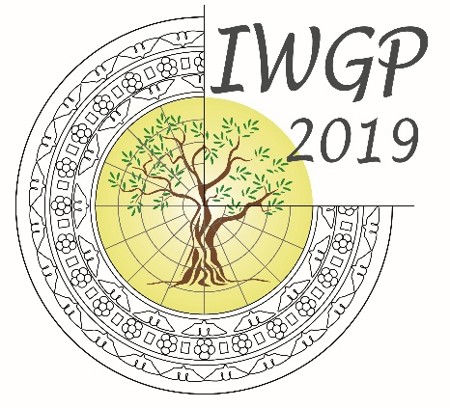
18TH CONFERENCE
OF THE INTERNATIONAL WORKGROUP FOR PALAEOETHNOBOTANY

Lecce, 3rd-8th June 2019

ABSTRACT FORM

Proposal for Poster/Oral presentation (please indicate your choice)

TITLE Times New Roman 12 pt
Name(s) of author(s) Times New Roman 11 pt
Institution of author(s) Times New Roman 10 pt
E-mail address Times New Roman 10 pt

Key-words (max 5) Times new Roman 10 pt italics
Abstract (max 1500 characters, including spaces) Times New Roman 10 pt

