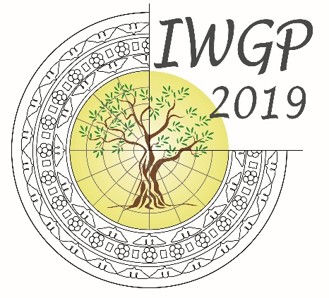
18TH CONFERENCE
OF THE INTERNATIONAL WORKGROUP FOR PALAEOETHNOBOTANY

Lecce, 3rd-8th June 2019

PAYMENT CONFIRMATION FORM

Registration TYPE | LAST NAME | FIRST NAME | FEE
Total amount

Payment type | Bank transfer | Paypal

mail this form, together with a copy of the bank transfer order, or the paypal payment, to the organizing committee at iwgp2019lecce@unisalento.it

