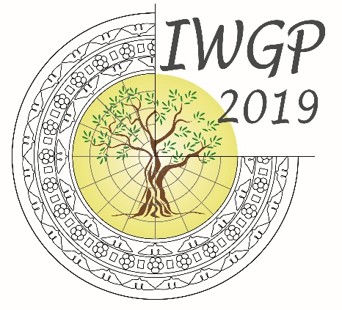
18TH CONFERENCE
OF THE INTERNATIONAL WORKGROUP FOR PALAEOETHNOBOTANY

Lecce, 3rd-8th June 2019

18° IWGP2019 - 2nd Circular and call for abstract

Dear Colleagues,
We are pleased to inform you that more than two-hundred and seventy peers submitted pre-registration forms to 18Th IWGP that will be hosted in Lecce at the University of Salento.

You are invited to submit an abstract for consideration as an oral or poster presentation. If you choose to present at the conference, you must submit an abstract electronically.
The submitted abstracts will be evaluated for acceptance by members of the organizing and the scientific committees.

If you are selected for a talk or abstract, you will be notified at least one month prior to the start of the conference.

Each registrant may only present one poster or talk as leading author, the deadline to submit the abstract is January 15th 2019.

In order to complete the submission of the abstract you should follow this link: http://conference.unisalento.it/ocs/index.php/iwgp2019/iwgp2019.
Please note that you need to enter the username and password given you during pre-registration process.
Please note that presenters must also be registered at the meeting.

In order to facilitate those of you that prefer to complete the registration sooner, the on-line payment procedure is now opened.
The fees for the Early bird registration is 150 Euro for students and 250 Euro for scholars, the new deadline is April 15th 2019.
After this date, the inscription fee will increase to 250 and 350 Euro, respectively.

http://conference.unisalento.it/ocs/index.php/iwgp2019/iwgp2019/schedConf/registration

The Social Dinner is scheduled for Thursday 6th of June 2019 and will be held in the beautiful medieval fortified tower ‘Torre del Parco’ (https://www.torredelparco.com/en/).

Yours sincerely
The steering Commitee

