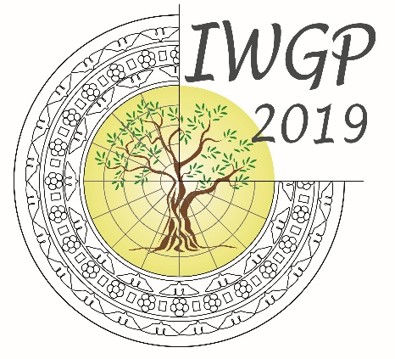
18TH CONFERENCE
OF THE INTERNATIONAL WORKGROUP FOR PALAEOETHNOBOTANY

Lecce, 3rd-8th June 2019

PRE-REGISTRATION FORM

PARTICIPANT INFORMATION
Family name |  | Name
Title
Institution
Address
Email
Fax
Telephone

REGISTRATION
I will attend the conference
Form of presentation |  | Communication |  | poster
Author(s)
Preliminary title

Please indicate the sessions/laboratories/workshops you intend to join. Multiple choices are allowed.

Forms to be returned before September 1st 2018

- ORIGINS AND DIFFUSION OF CULTIVATED PLANTS
- Absolute chronology on plant remains
- Morphological changes and domestication
- Regional perspectives
- AGRICULTURAL PRACTICES AND PALAEOECONOMY
- Irrigation/Manuring/Crop rotation....
- Introduction of new “exotic” crops beyond their natural habitat
- Plant-Based Food and Plant Food Processing
- Agriculture and innovation in the Mediterranean
- INTEGRATED AND INTERDISCIPLINARY APPROACHES
- Ethnobotany
- Experimental approaches
- Plants iconography/literary sources
- Plant genetics and ancient DNA
- FIBS/weeds
- Isotopes
- PLANTS AND SOCIETY
- Crops and surplus production
- Food and drink and their social meaning
- Arboriculture and complex society
- Plants in rituals
- Plants in medicine
LABORATORY SESSIONS
- Naked wheats
- New glume wheat
- Image analysis
- Legumes
- Millets
Workshops
- ERC projects
- National and international archaeobotanical networks
- Archaeobotany and public

